# MLX90640 (IR sensor)



# ILI9341 (TFT LCD)

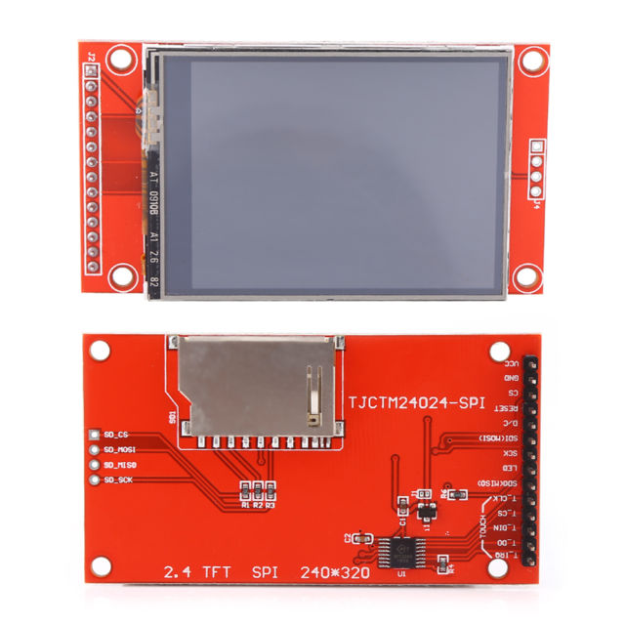

# NodeMCU (ESP8266)

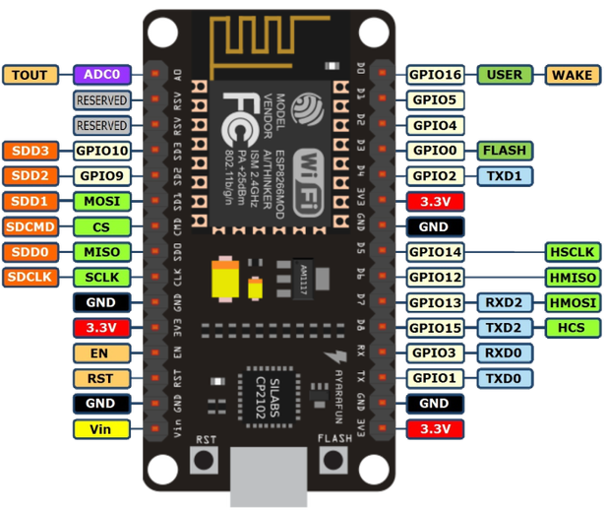

Connection of IR sensor:

D1 GPIO5 SCL

D2 GPIO4 SDA

Connection of LCD:

|  |  |  |  |  |
| --- | --- | --- | --- | --- |
| LCD | | NodeMCU | | Notes |
| pin | Name |  | GPIO |  |
| 1 | VCC | 3,3/5V | - |  |
| 2 | GND | GND | - |  |
| 3 | CS | D8 | 0 |  |
| 4 | RESET | RESET/3,3V | - | RESET of NodeMCU or 3,3V or some GPIO if needed |
| 5 | DC | D9 | 2 |  |
| 6 | MOSI | MOSI/D7 | 13 |  |
| 7 | SCK | D5/SCK | 14 |  |
| 8 | LED | 3,3/5V cez R | - |  |
| 9 | MISO | D6/NC | 12 | Optional – needed only if read from LCD is needed |

Connection of touch sensor:

Connection of SD card reader: